A000-Afr-Niger-Bura Head-Triangular-Terra Cotta-3rd to 11th century CE

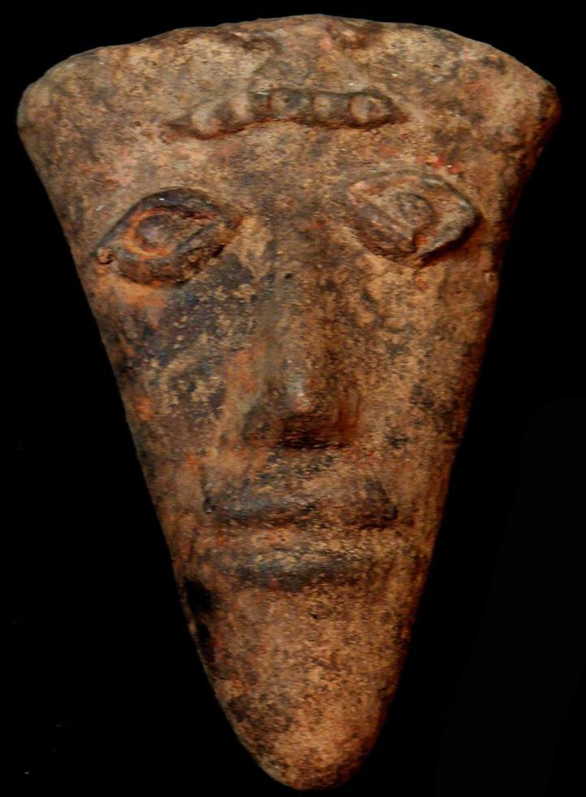

Fig. 1. Afr-Niger-Bura Head-Triangular-Terra Cotta-3rd to 11th century CE

Case No.: 6

**Accession No.**

**Formal Label: A**fr-Niger-Bura Head-Triangular-Terra Cotta-3rd to 11th century CE

**Display Description:**

The general articulation of the system of occupation of space sites in Bura seems to revolve around two poles, the necropolis and the religious altar. The necropolis is almost always located in protected places. In the necropolis, anthropomorphic terracotta coffins or anthropomorphic funerary urns were laid upside down on the original floor and were then covered by a remobilization of the wind after the 13th century.  
 Funerary urns are generally surmounted by heads of anthropoid statuettes presenting a generally anthropomorphic form. Three types of funerary urns can be distinguished:  
    1. Longiform or tabular vases 70 to 80 cm high and 10 to 30 cm in diameter, surmounted either by complete statuettes of a person or mounted rider. These vases serve as supports for statuettes and sometimes form their bodies.  
    2. Hemispheric vases 20 to 40 cm high and 10 to 30 cm in diameter generally topped by statuette heads. This is probably the origin of the current terra cotta head.   
    3. Semi-ovoid jars, approximately 50 to 70 cm in diameter and 40 to 60 cm in diameter, supporting either complete statuettes or statuette heads.

**LC Classification:**

**Date or Time Horizon:** 3rd to 11th century CE

**Geographical Area: Niger River delta**

**Map:**

**GPS coordinates:**

**Cultural Affiliation:**

**Media:**

**Dimensions: H** 7.87 in

**Weight:** 3.06 pounds

**Condition:**

**Provenance:**

**Discussion:**

**References:**

